Deliverable 4: Wireframes & Feature Plan
CSC425 Fall 2025
Student Name: Megan Jones
Date Submitted: 09/20/2025
GitHub REPO URL: https://github.com/MJONES155/CSC425_Assignment1
Branch Name: Deliverable4-MeganJones

1. Low-Fidelity Wireframes (Mobile-First)
Create Account Screen
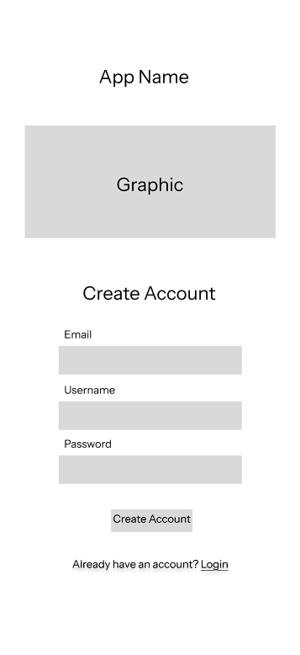
Elements:
- Email Input
- Username input
- Password input
- Create Account button
- “Login” link
Login Screen
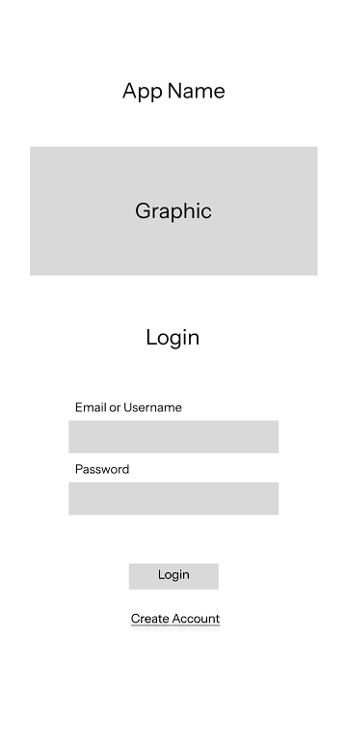
Elements:
- Email/Username input
- Password input
- Login button
- “Create Account” link
Dashboard Screen
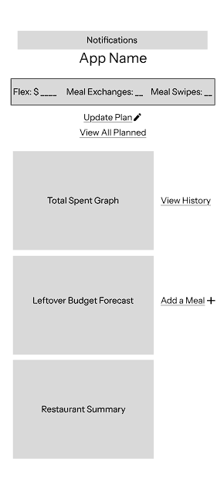
Elements:
- Graphics: total spent, amount spent over time, restaurants visited, weekly budget tracking
- Buttons: Input Meal Plan, View History
- Notifications section
Input Screens
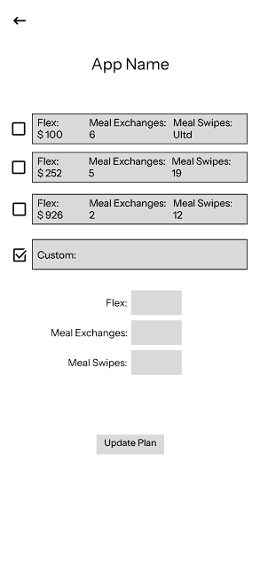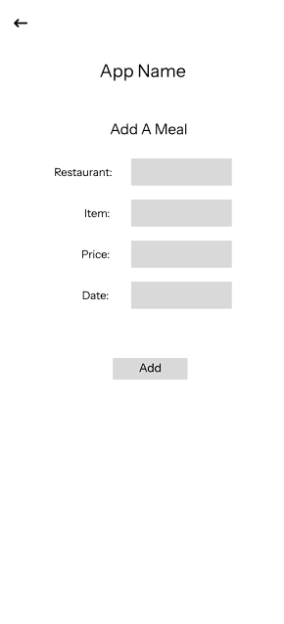
Screens:
- Enter Flex Amount/ Select Meal Plan
- Enter Meal Prices per restaurant
Additional Major Screens
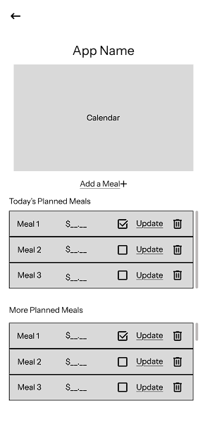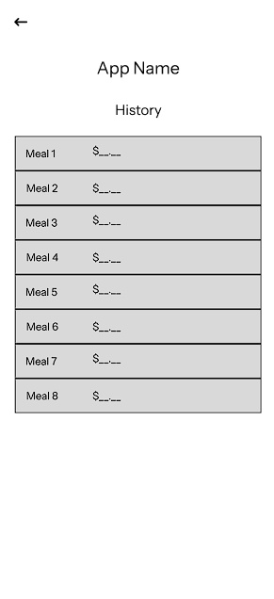
Screens:
- Planned Page
- Meal History

2. Functional Requirements
- User Authentication: Sign Up, Login, Logout, Password Security
- CRUD Operations:
  - Meal Plans
  - Flex Amounts
  - Meal Entries per Restaurant
  - Login Credentials
- Navigation: Between Create Account → Login → Dashboard → Input Features Or Additional Screens
- Data Persistence: Backend Integration To Store User Account Info, Meal Plans, Flex Amounts, Restaurant Visits
- Visuals/Graphs: Total Spent, Spending Over Time, Restaurants Visited, Weekly Budget Planning
  - Graph Calculations: Automatic calculations for totals, averages, and projections
- Notifications: Weekly spending alerts if budget not fully utilized.
- Input Validation: Meal prices and flex amounts/meal plan entries must be validated
- Error Handling: Login Errors, Database Errors, Invalid Inputs
- Responsive Design: Mobile-first layout with adaptability for larger screens.

3. User Stories
- As a student, I want to see my leftover flex amount, so that I can budget for other expenses.
- As a student, I want to plan my spending ahead, so that I don’t run out of my flex or have leftover money at the end of the year.
- As a student, I want to know which restaurants I have visited, so that I can track my meal plan usage.
- As a student, I want notifications if I have not spent my weekly budgeted amount, so that I can adjust my spending accordingly.
- As a student, I want to input individual meal prices, so that I can see how each meal fits into my overall budget.

4. User Journey Flow
Option A: Flow Diagram
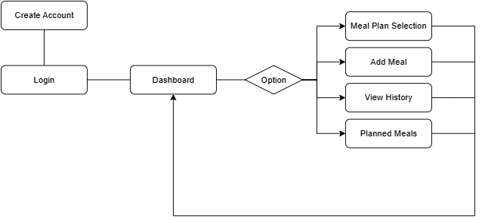
Note:
- This is my individual submission. The team will review all submissions and agree on a final
version for project continuation.

